A PROJECT REPORT ON

DeepFake Analysis

SUBMITTED TO

DR. D. Y. PATIL SCHOOL OF SCIENCE & TECHNOLOGY,
DR. D. Y. PATIL VIDYAPEETH, PUNE

In the partial fulfillment of the requirements
For the award of the degree
OF

BACHELOR OF TECHNOLOGY
ARTIFICIAL INTELLIGENCE & DATA SCIENCE

SUBMITTED BY

Mr. Shaunak Chorge 10
Mr. Prasanna Patil 38
Ms. Tejasvi Yellamelli



DEPARTMENT OF
ARTIFICIAL INTELLIGENCE & DATA SCIENCE

DR. D.Y.PATIL SCHOOL OF SCIENCE & TECHNOLOGY, TATHAWADE, PUNE

DR. D. Y. PATIL VIDYAPEETH, PUNE 2024 -2025


CERTIFICATE

This is to certify that the project report entitled

“DeepFake Analysis”

Submitted by
Mr. Shaunak Chorge 10
Mr. Prasanna Patil 38
Ms. Tejasvi Yellamelli

is a bonafide student of this institute and the work has been carried out by him/her under the supervision of Mrs. Shradha Shilwant and it is approved for the partial fulfillment of the requirement of Dr. D. D. Y. Patil Vidyapeeth, Pune, for the award of the degree of Bachelor of Technology (Artificial Intelligence & Data Science).

Mrs. Shradha Shilwant Dr. Mily Lal
Guide, Head,
Department of AI-DS Department of AI-DS

Dr. Manisha Bhende
Director I/C,
Dr. D. Y. Patil School of Science & Technology, Tathawade, Pune

Place: Pune Date:

ACKNOWLEDGEMENT
.

We would like to express our sincere gratitude to Dr. D. Y. Patil Vidyapeeth, Pune for providing us the opportunity to undertake this project titled “DeepFake Analysis” as a part of the curriculum of Bachelor of Technology in Artificial Intelligence & Data Science.
We are deeply indebted to our project guide, Mrs. Shradha Shilwant, for her invaluable guidance, constant encouragement, and insightful feedback throughout the duration of the project. Her mentorship has played a crucial role in shaping our work and understanding of the subject.
We extend our heartfelt thanks to Dr. Mily Lal, Head of the Department of AI-DS, for her support and for providing the necessary resources to carry out this project successfully. We also thank Dr. Manisha Bhende, Director I/C, for her continued motivation and for creating a conducive environment for research and innovation.
Lastly, we would like to thank all our faculty members, peers, and families for their encouragement and unwavering support during this project journey.

Student Name :
Mr. Shaunak Chorge
Mr. Prasanna Patil
Ms. Tejasvi Yellamelli
ABSTRACT

In recent years, DeepFake technology has emerged as a powerful tool that utilizes deep learning techniques, particularly Generative Adversarial Networks (GANs), to create hyper-realistic fake images and videos. While DeepFakes hold potential in entertainment and creative industries, their malicious use poses serious threats to cybersecurity, political stability, and personal privacy.
This project, titled “DeepFake Analysis”, focuses on detecting and analyzing DeepFake media using machine learning models trained on diverse datasets. The goal is to understand the key patterns in manipulated media and develop an automated detection system that can differentiate between authentic and fake content. We explore various feature extraction techniques, image forensics, and classification models to achieve reliable detection.
The project also emphasizes the security implications of DeepFakes and presents mitigation strategies to combat misinformation in the digital world. Our approach combines technical detection with awareness about the socio-ethical consequences of synthetic media, aiming to contribute meaningfully to the domain of Machine Learning and Network Security.

Keywords:
DeepFake, Machine Learning, Network Security, GANs, Media Forensics, Deep Learning, Fake Video Detection, AI Ethics, Cybersecurity

TABLE OF CONTENTS
LIST OF ABBREVIATIONS vii
LIST OF FIGURES viii

Sr.No. | Title of Chapter |  | Page No.
01 | Introduction |  | 9
1.1 | Overview |  | 9
1.2 | Motivation |  | 9
1.3 | Problem Definition And Objectives |  | 9
1.4 | Project Scope & Limitations |  | 10
02 | Literature Survey |  | 11
03 | Software Requirements Specification |  | 12
3.1 | Assumptions and Dependencies |  | 12
3.2 | Functional Requirements |  | 12
 | 3.2.1 | Reliable Score | 12
 | 3.2.2 | Secure Data Storage | 12
 | 3.2.3 | Intuitive Web Portal | 12
3.3 | External Interface Requirements |  | 12
 | 3.3.1 | User Interfaces | 12
 | 3.3.2 | Hardware Interfaces | 13
 | 3.3.3 | Software Interfaces | 13
 | 3.3.4 | Communication Interfaces | 13
3.4 | Nonfunctional Requirements |  | 14
 | 3.4.1 | Performance Requirements | 14
 | 3.4.2 | Security Requirements | 14
 | 3.4.3 | Safety Requirements | 14

3.5 | System Requirements |  | 15
 | 3.3.1 | Database Requirements | 15
 | 3.3.2 | Software Requirements (Platform Choice) | 15
 | 5.3.3 | Hardware Requirements | 15
3.6 | Analysis Models: SDLC Model to be applied |  | 16
04 | System Design |  | 17
4.1 | System Architecture |  | 17
05 | Project Plan |  | 18
5.1 | Project Estimate |  | 19
 | 5.1.1 | Reconciled Estimate | 20
 | 5.1.2 | Project Resources | 20
5.2 | Risk Management |  | 21
 | 5.2.1 | Risk Identification | 22
 | 5.2.2 | Risk Analysis | 23
 | 5.2.3 | Overview of Risk Mitigation, Monitoring and Management | 24
5.3 | Project Schedule |  | 26
 | 5.3.1 | Project Task Set | 26
 | 5.3.2 | Timeline Chart | 27
5.4 | Team Structure |  | 2
06 | Project Implementation |  | 24
6.1 | Overview of Project Modules |  | 24
6.2 | Tools and technologies used |  | 24

6.3 | Algorithm details |  | 26
 | 6.3.1 | Convolutional Neural Network (CNN) | 26
 | 6.3.2 | Logistic Regression Classifier | 26
 | 6.3.3 | Gradient Decent Algorithm | 26
 | 6.3.4 | Stochastic Gradient Decent (SGD) | 26
 | 6.3.5 | RMS Prop Algorithm | 27
07 | Results |  | 28
7.1 | Outcomes |  | 28
7.2 | Screenshots |  | 28
08 | Conclusions
8.1 | Conclusion |  | 31
8.2 | Future Scope |  | 31
8.3 | Applications |  | 31
 | References |  | 32

LIST OF ABBREVIATIONS

ABBREVIATION | FULL FORM
AI | Artificial Intelligence
ANN | Artificial Neural Network
IoT | Internet of Things
GUI | Graphical User Interface
P/F | Pass/Fail
DB | Database
RMC | Remote Method Call
WHO | World Health Organization
IEEE | Institute of Electrical and Electronics Engineers
ML | Machine Learning
DFDC | Deepfake Detection Challenge
UI | User Interface
URL | Uniform Resource Locator
API | Application Programming Interface

LIST OF FIGURES

Figure | Illustration | Page No.
3.1 | Prototype Model | 16
4.1 | Architecture Diagram | 17

- INTRODUCTION

Overview
DeepFakes are synthetic media—images, audio, and videos—created using deep learning techniques such as Generative Adversarial Networks (GANs). They are capable of mimicking real people’s appearances and voices, making it increasingly difficult to distinguish real from fake content. This project explores the use of Machine Learning models to analyze and detect DeepFakes, emphasizing the importance of digital media verification in the era of misinformation and cyber threats. The study incorporates tools and techniques from AI, computer vision, and network security domains.

Motivation
The rise in DeepFake-generated content poses a growing threat to society, especially in areas like politics, journalism, and personal security. Misuse of such technology can lead to identity theft, defamation, and spread of fake news. As students of Artificial Intelligence and Data Science, we were motivated to address this real-world challenge by building a detection system that can help in identifying manipulated media and promoting digital trust. Our aim is to contribute towards safeguarding public awareness and media authenticity..

Problem Definition And Objectives
Problem Definition:
To detect and analyze DeepFake videos using machine learning techniques and highlight their security implications in the digital ecosystem.

Objectives:
- To study the working of GANs and their role in generating DeepFake content.
- To collect and pre-process DeepFake datasets.
- To develop a DeepFake detection model using ML classification techniques.
- To evaluate the accuracy and performance of the model.
- To analyze the impact of DeepFakes on network security and suggest possible countermeasures.
.

Project Scope And Limitations
Scope:
The project focuses on detecting visual DeepFakes (images/videos) using machine learning models. It includes the analysis of datasets containing manipulated media, training of models on distinguishing real vs fake content, and understanding the broader implications of such technology on network security. The project is limited to academic research and prototype development.
Limitations:
- The model may not perform well on real-time or high-resolution DeepFakes outside the dataset.
- Audio-based DeepFakes and text manipulations are not covered.
- Limited computational resources may restrict training of deeper neural networks.
- Dataset size and quality may affect model generalization.
- Adversarial attacks may bypass detection mechanisms.
.

Literature Survey

Sr. No. | Paper Title, Journal Name, Year of Publication | Findings
1 | FaceForensics++: Learning to Detect Manipulated Facial Images, IEEE Transactions on Pattern Analysis and Machine Intelligence, 2020 | Introduced a large dataset for DeepFake detection and showed that deep learning classifiers can detect manipulations with high accuracy under ideal settings.
2 | DeepFakes and Beyond: A Survey of Face Manipulation and Fake Detection, ACM Computing Surveys, 2021 | Provided a comprehensive review of face manipulation techniques and detection methods; highlighted challenges in generalization and real-world applicability.
3 | Exposing DeepFake Videos By Detecting Face Warping Artifacts, CVPR Workshops, 2019 | Proposed a method to detect visual inconsistencies like warping artifacts around the face region caused during DeepFake generation.
4 | FakeCatcher: Detection of Synthetic Portrait Videos using Biological Signals, IEEE Transactions on Pattern Analysis and Machine Intelligence, 2022 | Used subtle biological signals like heart rate and facial blood flow inconsistencies to detect synthetic videos, achieving high robustness in real-world settings.

- Software Requirements Specification

Assumptions and Dependencies

- The assumptions are : The datasets used for training the DeepFake detection model are assumed to be correctly labeled (real/fake), balanced, and preprocessed. All input videos/images are assumed to be in standard formats (e.g., MP4, JPEG). Users interacting with the system have stable internet connectivity and supported devices.

- The dependencies are : The Deep Learning frameworks (e.g., TensorFlow, PyTorch) must be correctly configured and GPU support enabled for model training and inference. The model also depends on availability of pre-trained weights, and dataset sources such as FaceForensics++, DeepFake Detection Challenge (DFDC), etc.

Functional Requirements

    - The system will upload and accept image/video inputs from users through a web interface.

    - The system will process the uploaded media using a trained Convolutional Neural Network (CNN) to detect manipulated content.

    - The system will return three types of output:
      - Probability score (Real/Fake Confidence %)
      - Manipulated region visualization (optional heatmap output).
      - Suggestive feedback or classification label ("Likely DeepFake", "Authentic", "Uncertain").

External Interface Requirements

    - User Interfaces
      - A responsive web interface allowing users to upload video/image files for analysis.
      - Dashboard to display detection results with visualization and metadata..

    - Hardware Interfaces
      - GPU-enabled machine (e.g., NVIDIA RTX series) for real-time or near real-time DeepFake detection.
      - High-resolution display for reviewing video frames and detection overlays.

    - Software Interfaces
      - Frontend: HTML, CSS, JavaScript (React or Flask templates).
      - Backend: Python with Flask/Django, integrated with OpenCV, TensorFlow/PyTorch.
      - File handling with media processing libraries like FFmpeg, MoviePy, and PIL.

    - Communication Interfaces
      - REST APIs for sending and receiving video data between frontend and backend.
      - JSON response format for real-time model inference.
      - Secure HTTPS protocols for all user communications and uploads.

Non-functional Requirements

    - Performance Requirement
      - The model should detect and return results within 10 seconds for short videos (<10 sec).
      - Accuracy should be at least 85% on benchmark datasets.

    - Security Requirement
      - Uploaded media must be securely stored and deleted after processing.
      - All communication is encrypted using SSL.
      - User data is not logged or reused without permission.

    - Safety Requirements
      - The system must not falsely accuse authentic content. A threshold score should be adjustable to reduce false positives.
      - Only authorized users should be allowed access to internal system components.

System Requirements

    - Database Requirements
      - A lightweight NoSQL (e.g., MongoDB) or SQLite database to temporarily store upload history and inference results.
      - Cloud storage integration (e.g., Firebase or AWS S3) for temporary media uploads.

    - Software Requirements (Platform Choice)
      - Python 3.8+
      - TensorFlow or PyTorch for model development
      - OpenCV for image/video processing
      - Flask/Django for backend
      - HTML/CSS/JS for frontend

    - Hardware Requirements
      - Minimum: 8 GB RAM, i5 Processor, NVIDIA GTX 1050 or above GPU
      - Recommended: 16 GB RAM, i7 Processor, NVIDIA RTX 3060 or above GPU

Analysis Models: SDLC Model to be applied

Prototyping Model
The Prototyping SDLC model is used to iteratively develop and refine the DeepFake Detection System. A working prototype is built to demonstrate functionality (e.g., detection accuracy, interface usability), which helps gather early feedback from users and stakeholders. Based on this feedback, enhancements are implemented until the final system is ready.
.

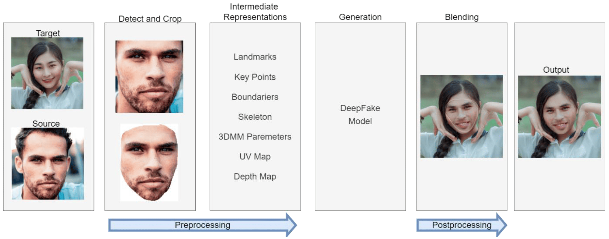

System Design

  - System Architecture

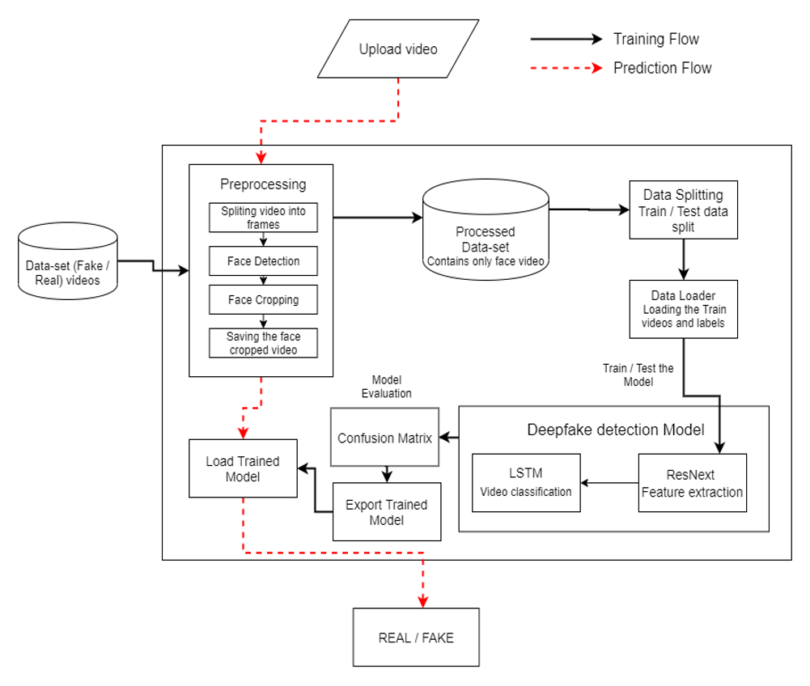

Project Plan

Project Estimate

- Communication :-
  - Transaction Details: Secure transfer of training datasets, pre-trained models, and configuration files.
  - Requirement Gathering : Collection of deepfake datasets, expected system output formats, UI/UX requirements from end users like legal officials or forensic experts.
- Plan :-
  - Algorithm Analysis : Study and evaluation of deep learning-based detection algorithms (e.g., CNN, RNN, EfficientNet, Xception) for identifying facial manipulations and synthetic content.
- Design :-
  - Interface Design: Designing a simple, intuitive interface for uploading videos/images and displaying detection results.
  - Database Design: Structuring a secure storage system for uploaded media, processed results, and user logs.
  - Back End Design: Designing APIs for model inference, result generation, and feedback handling.
- Code :-
  - Construction of Front End : Development of a web-based user portal with functionality to upload media and view authenticity scores.
  - Construction of Back End: Setting up a Flask-based backend for managing video/image input, communication with the detection model, and result retrieval.
  - Construction and training of ANN model: Building and training a deep learning model (e.g., using CNN or Xception) to differentiate between real and manipulated media.
- Test:-
  - Test of device and modules: Testing Raspberry Pi integration (if used for edge deployment) and interface responsiveness.
  - Test of ANN model: Model evaluation using metrics such as Accuracy, Precision, Recall, F1 Score on standard deepfake datasets (e.g., DFDC, FaceForensics++).

    - Reconciled Estimates:

● 5.1.1.1 Cost Estimate:
Resource | Estimated Cost
Hardware (Raspberry Pi, camera) | ₹3,500
Cloud Deployment (Heroku/Firebase) | ₹1,000/month
Training (GPU, dataset access if paid) | ₹5,000
Miscellaneous | ₹1,500
Total Estimated Cost | ₹11,000+

● 5.1.1.2 Time Estimate:
Phase | Duration
Requirement Analysis | 1 week
Algorithm & Model Training | 2–3 weeks
Front-End & Back-End Dev | 2 weeks
Integration & Testing | 1–2 weeks
Deployment & Finalization | 1 week
Total Duration | 7–9 weeks

    - Project Resources:

      - People:
        - ML / Developers
        - End Users (Forensic Analysts / Legal Authorities / Cybercrime Officials)
      - Hardware:
        - Raspberry Pi (optional – for edge deployment)
        - Webcam or Camera module (if real-time capture is included)
      - Software:
        - Python (with libraries like TensorFlow, Keras, OpenCV, NumPy)
        - Flask (for backend)
        - HTML/CSS/JS (for frontend)
        - Heroku/Firebase (for deployment and database
        - Jupyter or Anaconda (for ML model training).

Risk Management

    - Risk Identification
roject Risk Management includes the processes of risk planning, identification, analysis, response planning, and control. The primary goal is to increase the probability and impact of positive events and reduce those of negative events.
In the Deepfake Detection System, risk is minimized due to:
      - Clearly defined end-user requirements.
      - Use of well-documented datasets and APIs.
      - A skilled development team familiar with machine learning, deep learning, and web technologies.

    - Risk Analysis

Risks for the project have been analyzed based on Schedule, Quality, and Overall impact.

ID | Risk Description | Probability | Schedule Impact | Quality Impact | Overall Impact
1 | Model overfitting due to limited data | Low | Low | High | High
2 | Video processing time too high | Medium | High | Medium | High
3 | Dataset bias affecting detection accuracy | Medium | Low | High | High
4 | Deployment issues on Heroku/Cloud | Low | Medium | Medium | Medium
5 | Compatibility issues with input formats | Low | Low | Medium | Medium

Table: Risk Table

Probability | Value | Description
High | Probability of occurrence is | > 75%
Medium | Probability of occurrence is | 26-75%
Low | Probability of occurrence is | <25%

Table: Risk Probability Definitions

Impact | Value | Description
Very High | >10% | Critical delay or failure, unacceptable model accuracy
High | 5–10% | Notable degradation in detection or feature functionality
Medium | <5% | Slight performance drop, manageable quality issues
Low | Minimal | Barely noticeable, can be absorbed into schedule

Table:Risk Impact Definitions

    - Overview of Risk Mitigation, Monitoring and Management

Risk ID | Risk Description | Category | Source | Probability | Impact | Response | Strategy | Risk Status
1 | Model overfitting due to limited data | Machine Learning Model | Dataset analysis during model training | Low | Medium | Mitigate | Use regularization techniques, cross-validation | Identified
2 | Incomplete or noisy data | Requirements | Data preprocessing phase | Medium | High | Mitigate | Improve dataset quality and conduct data cleaning | Identified
3 | Low network connectivity during upload | Technology | Testing phase | Medium | Very High | Accept | Enable background uploads or retry mechanism | Identified
4 | Cloud deployment failure | Deployment | During deployment testing | Low | Medium | Avoid | Use robust CI/CD pipeline with Heroku/Firebase fallback | Mitigated
5 | Format mismatch in user-uploaded videos | Input/UX | UI testing and validations | Low | Medium | Mitigate | Add format validation and conversion before processing | Identified

Project Schedule

    - Project Task Set
The major project tasks are divided as follows:
      - Interface Design
      - Create a simple, intuitive UI for video/image upload and displaying deepfake analysis results.

      - Web Portal & Backend Modules
      - Set up Flask APIs, connect frontend to backend, and enable user access and login system.

      - Data Gathering & Preprocessing for ANN Model
      - Collect deepfake datasets (e.g., DFDC, FaceForensics++)
      - Process and label data for training.

      - Build ANN Model and Create Database
      - Train CNN/XceptionNet model to detect manipulations.
      - Set up a database to store results and user input.

      - Test Case Design
      - Write test cases for various modules, including the model, API responses, and UI functionality.

      - Integration of All Modules and Systems
      - Combine frontend, backend, model, and database into one complete system.

      - Testing and Debugging
      - Run end-to-end tests.
      - Resolve UI bugs, model issues, or cloud deployment problems.

Project Implementation

Overview of Project Modules
This project is focused on Deepfake Detection using AI-based video and image analysis. The system allows users to upload video or image files through a web portal, where deep learning models analyze and predict whether the content is real or manipulated.
The platform includes a User Authentication Module for Sign-Up and Login to ensure secure access. Users are categorized as Administrators and General Users. Admins can manage user accounts and view analytics, while general users can test media files for deepfakes.
The Deepfake Detection Module includes pre-processing tools (e.g., frame extraction, face detection) and a trained Artificial Neural Network (ANN) model that performs classification. Detected results are stored and tracked using the Database Module, which also logs user activities and detection history. Emphasis is placed on user privacy, secure file handling, and system integrity.

Tools and Technologies Used

Technologies:
- Web Development
- Deep Learning & Computer Vision
- Artificial Intelligence (AI)

Programming Language:
- Python
- JavaScript
- HTML / CSS

Operating Systems:
- Windows/Linux for local development
- Cloud Platform (Heroku/AWS) for deployment

Software Tools:
- TensorFlow / Keras for deep learning
- OpenCV for image and video processing
- Flask / Django for backend server
- Firebase / MongoDB for database and authentication
- Heroku or AWS for cloud deployment

Hardware:

- High-performance GPU system (for training/testing the deep learning model)

Algorithm Details:

    - Convolutional Neural Network (CNN)

CNNs are used to extract spatial features from video frames or images. Layers of convolution and pooling allow the model to learn patterns like facial structure, inconsistencies in lighting, or image tampering—key features in identifying deepfakes.

    - Logistic Regression Classifier

After feature extraction, a logistic regression layer is used as the final classifier to categorize media as Real (0) or Fake (1). It uses the sigmoid function to map outputs to probabilities in the [0, 1] range.

    - Gradient Descent Algorithm

Used for minimizing the model’s loss function during training. The algorithm iteratively adjusts weights in the direction that reduces prediction errors by using the gradient of the loss function.

    - Stochastic Gradient Descent (SGD)

Instead of using the entire dataset, SGD randomly selects samples in each iteration to speed up the training process and introduce variability that can improve generalization in the model.

    - RMSProp Algorithm

An advanced optimization method that adjusts the learning rate adaptively using a moving average of squared gradients. It stabilizes and accelerates convergence during training, especially useful for noisy or fluctuating datasets like deepfakes.

Results

Outcomes
The Deepfake Detection System successfully identifies manipulated video and image content using advanced deep learning techniques. The trained model, based on Convolutional Neural Networks (CNNs), achieves high accuracy in classifying media as real or fake.
- The system can detect deepfake content with significant precision even in compressed or low-resolution videos.
- It supports both image and video uploads and generates a probability-based prediction score for authenticity.
- Early detection of manipulated media ensures improved content moderation, trustworthiness, and platform integrity in digital ecosystems.
- The solution can also be integrated with media verification portals or used for real-time monitoring in social media platforms or journalism.

  - Screenshots

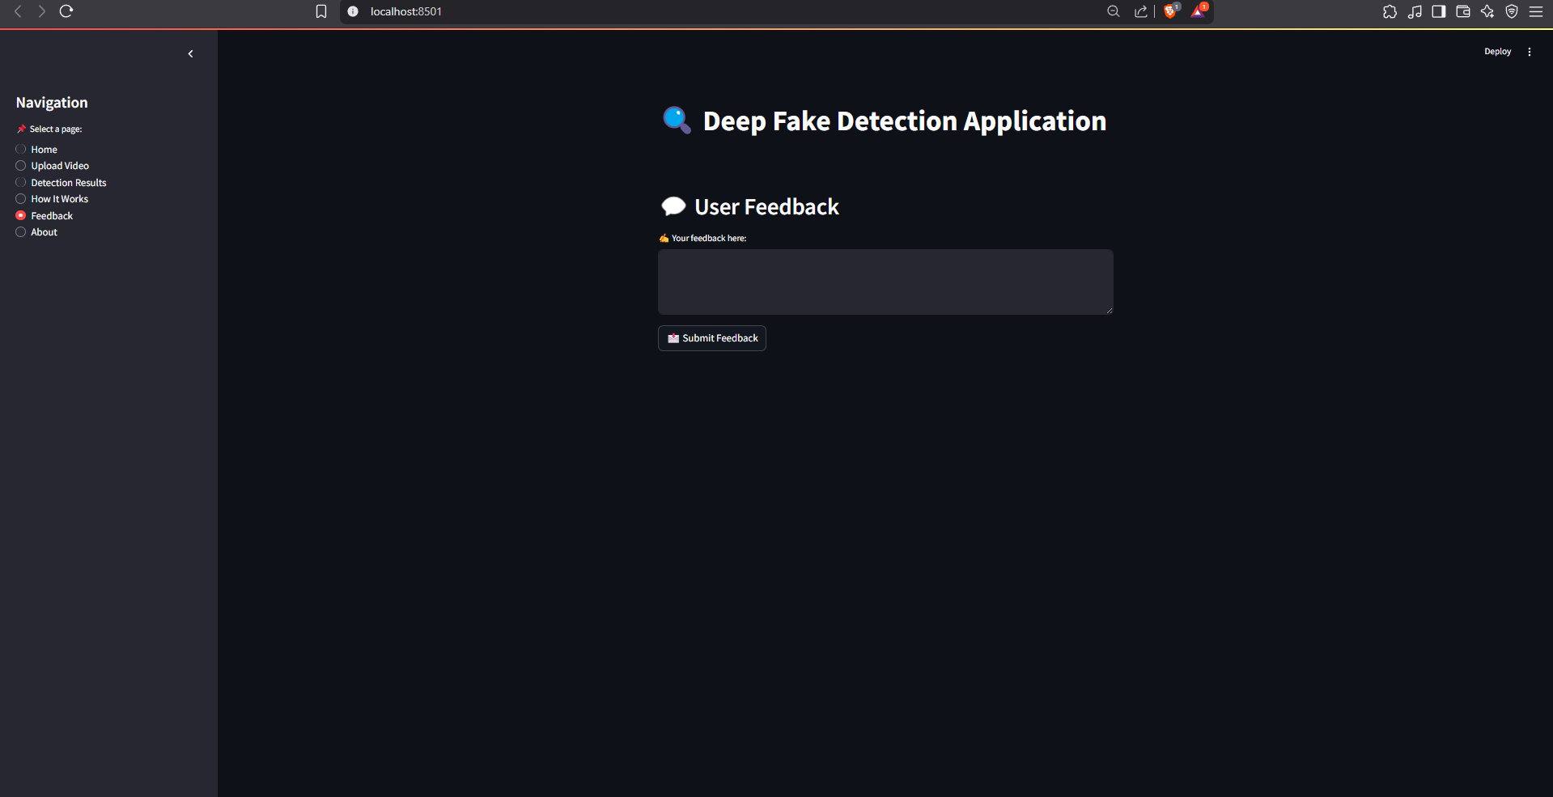

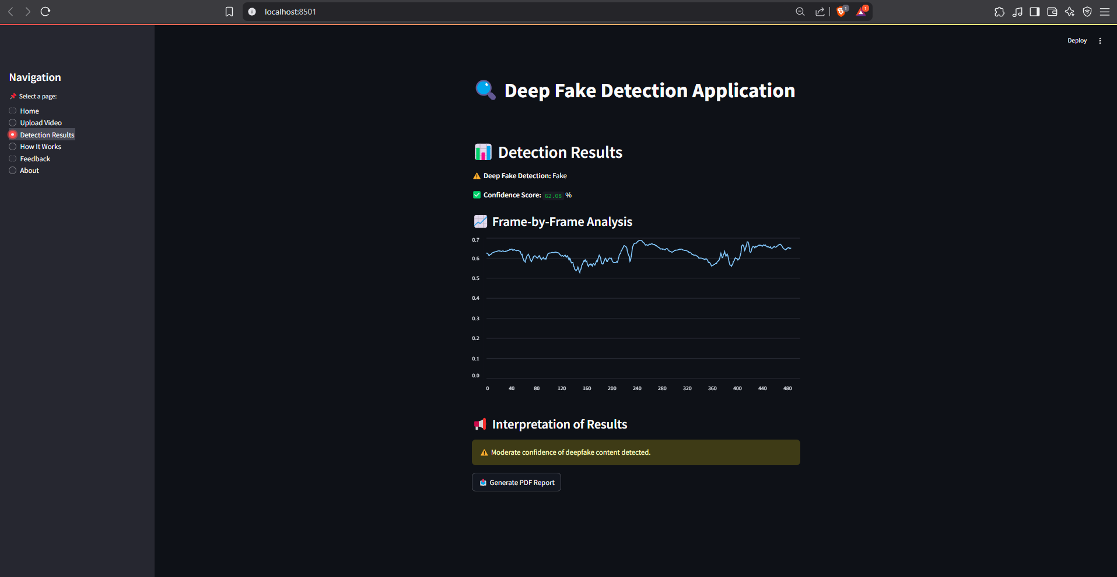

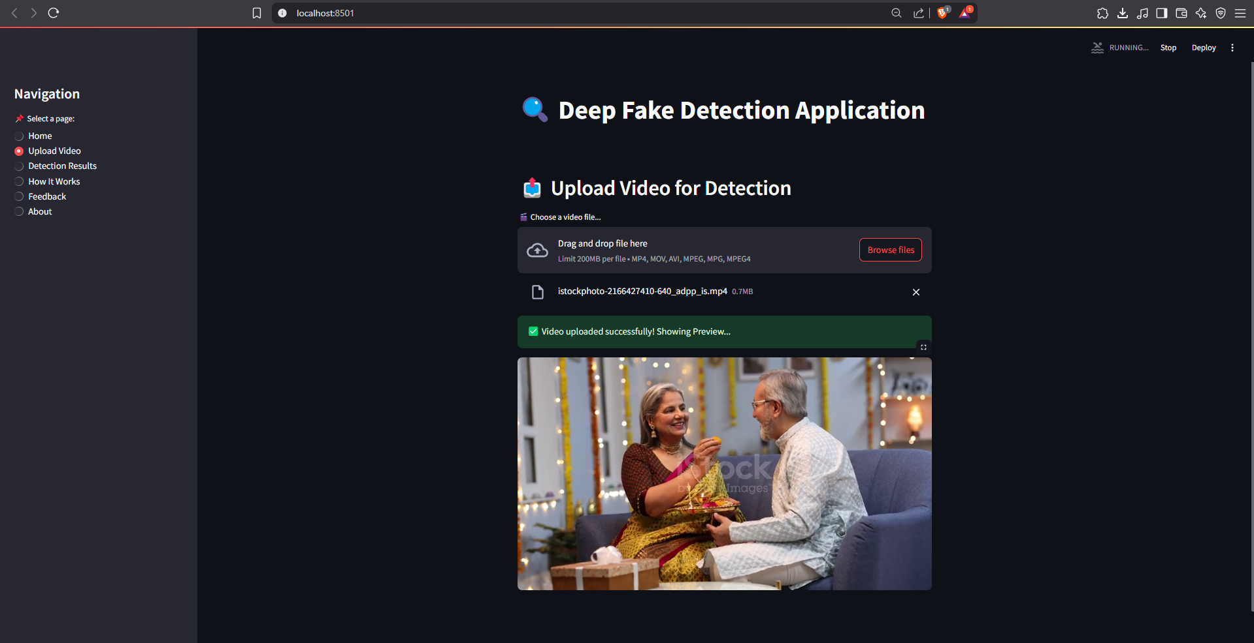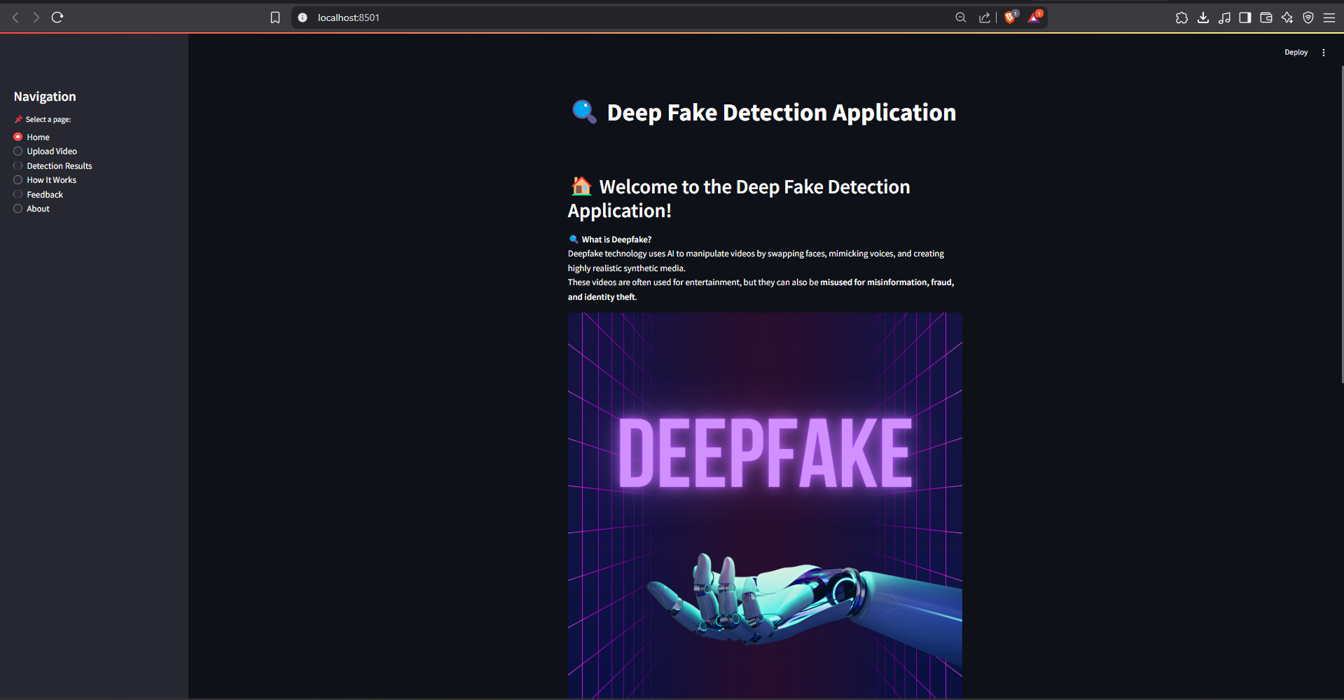

Conclusion

Conclusion
The Deepfake Detection System achieves its primary goal of accurately detecting altered media using a trained deep learning model. The project combines technologies such as CNNs, Flask-based API, and a user-friendly web interface to deliver real-time verification of visual content.
- The core algorithm uses a CNN trained on labeled datasets with optimization via Stochastic Gradient Descent (SGD) and RMSProp.
- The system provides a probability-based authenticity score and flags deepfakes for further investigation.
- The project is deployable on cloud platforms and stores results securely for future audit
.

Future Scope
- The detection model can be further improved with transformer-based architectures (e.g., Vision Transformers) for better generalization.
- Real-time video stream verification can be integrated for live applications in broadcasting and surveillance.
- Mobile apps can be developed for public use, allowing users to scan and verify media instantly.
- Integration with social media APIs for flagging fake content before it goes viral..

Applications
The Deepfake Detection System has versatile real-world applications, including:
- Law Enforcement & Cybercrime Units – Detect and trace manipulated videos used in scams or defamation.
- Journalism & Media Verification – Validate user-generated content before publishing.
- Corporate HR & Interviews – Ensure video-based hiring processes are legitimate.
- Social Media Platforms – Automated moderation of fake content.
- Education & Research – Demonstrating ethical AI usage and media literacy.
- Legal & Forensics – Provide verifiable evidence in legal investigations.

Reference

- H. Gupta and D. R. Vincent P.M., "A Centralized System to Support Health Care in India Using Cloud," 2017 International Conference on Intelligent Computing, Instrumentation and Control Technologies (ICICICT), 2017.

- World Health Organization (WHO), "Core Health Indicators," [Online]. Available: http://www.who.int

- L. Mertz, "Chain Reaction: Blockchain Applications in Health and Security," IEEE Computer Society, vol. 50, no. 3, pp. 7–9, 2018.

- M. Sordo, "Introduction to Neural Networks in Healthcare," OpenClinical, Oct. 2002.

- C. C. Bellos, A. Papadopoulos, R. Rosso, and D. I. Fotiadis, "Extraction and Analysis of Features Acquired by Wearable Sensor Networks," 2010 IEEE Conference, pp. 1–6.

- P. Baldi, "Gradient Descent Learning Algorithm," IEEE Transactions, vol. 8, pp. 1–10, 1995.

- X. Wen, F. Meng, L. Gao, H. Pang, and Y. Si, "Research on Distributed Database System Based on Remote Method Call," 2010 3rd Int. Conf. on Information Management, Innovation Management and Industrial Engineering, pp. 1–4.

- G. Zhang, C. Li, Y. Zhang, C. Xing, and J. Yang, "SemanMedical: A Semantic Medical Monitoring Model Based on IoT Sensors," 2012 IEEE 14th Int. Conf. on e-Health Networking, Applications and Services (Healthcom).

- K. Shailaja, B. Seetharamulu, and M. A. Jabbar, "Machine Learning in Healthcare: A Review," 2018 2nd Int. Conf. on Electronics, Communication and Aerospace Technology (ICECA), pp. 910–914.

- L. T. Herren, B. L. Robey, and P. K. Fink, "A Multi-Agent, Knowledge-Based System for Planning and Scheduling Medical Tests," Proceedings of the Sixth Annual IEEE Symposium on Computer-Based Medical Systems, 1993.

